Day 9: 5 Oct 2024

Micro Service : micro means small. Small service responsible to do simple or small task. Using micro service we can create more than one service develop using same language or different language with same db or different db and deploy independently with different port number in same type of server or different type of server.

Before Micro Service

Login module : LoginController, Login entity , LoginService, LoginRepostory and database.

Customer module

Product module

Order module

Payment module

Etc

After develop all the modules we need to merge those module or integrate those module in shared repository ie github.

After merge all team code we need to re-build ie create jar or war file and test it and deploy on production environment.

1. One module or team depends upon another team module or code.
2. If we want to do any changes, after changes on that particular module we need to re compile and rebuild and deploy
3. If any module get any issue the whole application can’t work.
4. All modules develop using same language with same database.

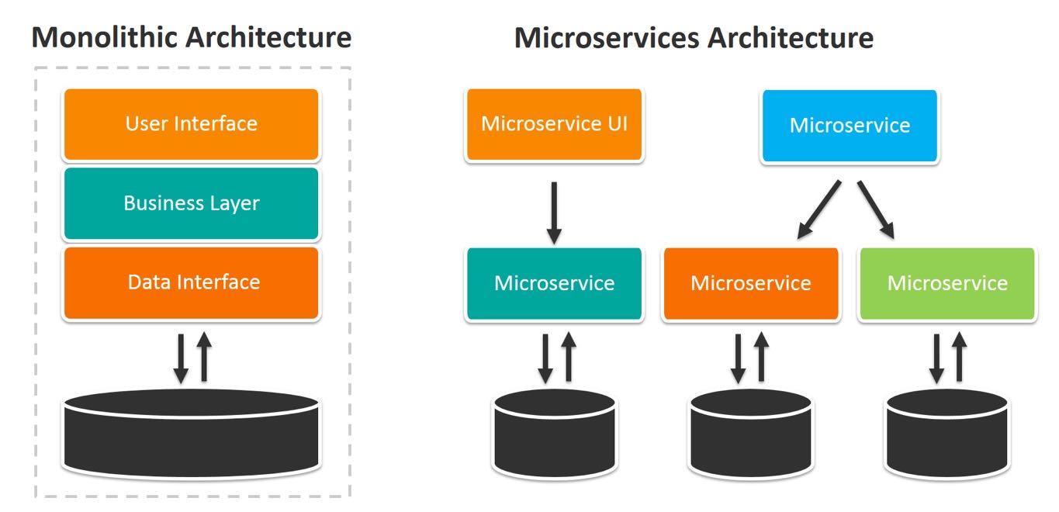

To implements this micro service using spring boot.

Spring boot provided two modules

Spring cloud

Spring micro service

Spring cloud provided one of the pre defined open source server ie EurekaServer part of Netflix. This server help us to deploy more than one micro service created using same language or different language.

This server keep the track about health of the service.

1s project creating Eureka Server

Starter -🡪 Eureka Server

Starter 🡪 Web Starter

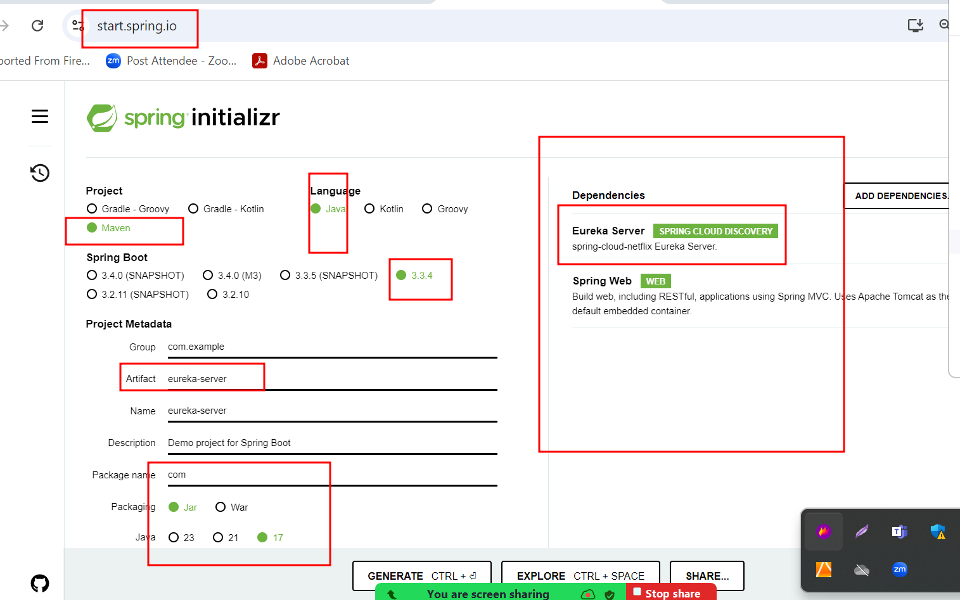

Eureka Server default port number is 8761. Because we added web starter which contains tomcat so Eureka server by default run on port number 8080.

But whenever we run more than one micro service project in application.properties file we need to mention eureka server running on port number 8080. Because each micro service search eureka server by default on same machine ie localhost with port number 8761.

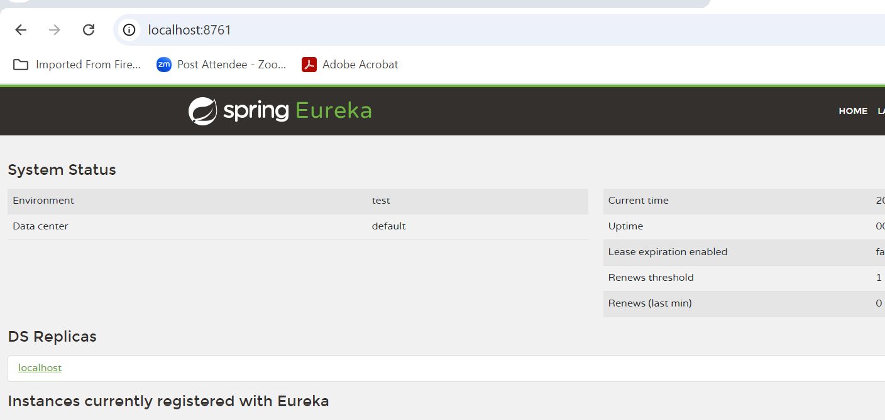

Now we can create more than one micro service.

2nd : first_micro_service : this project help us to create simple end point or rest api

Starter 🡪Web Starter

Starter 🡪Eureka Discovery client

Port number : 9191

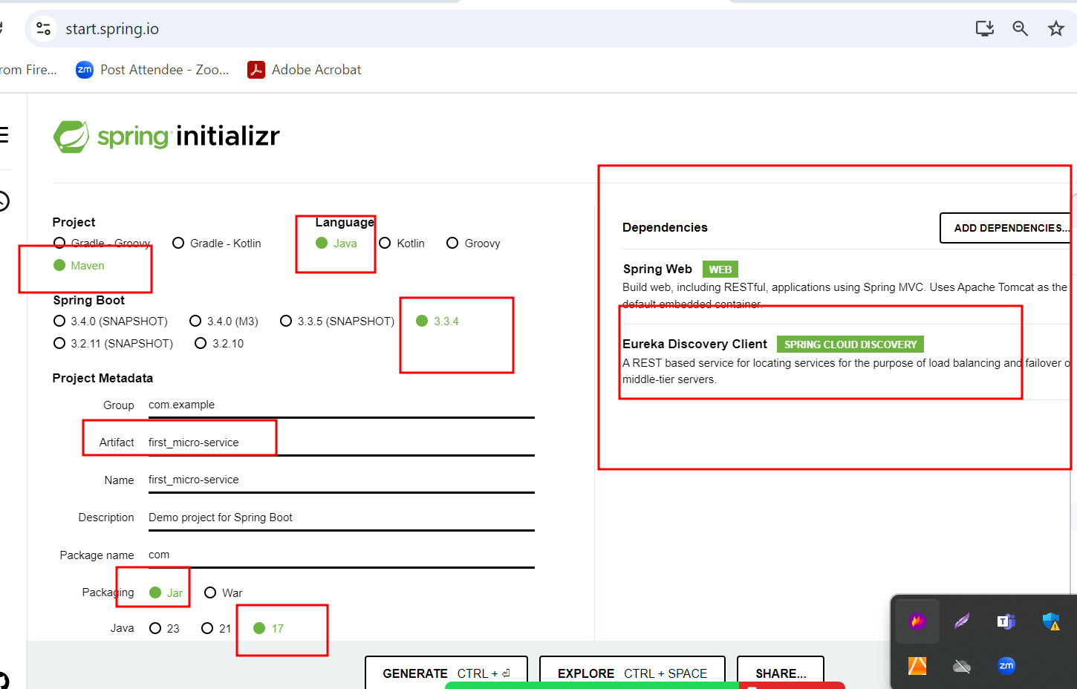

3rd : second_micro_service : this project help us to create simple end point or rest api

Starter 🡪Web Starter

Starter 🡪Eureka Discovery client

Port number : 9292

